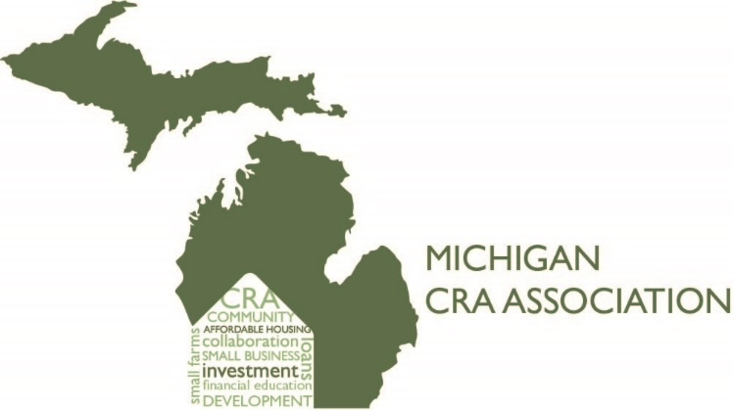

Macomb County CRA Association
President’s Report for 2019

Our Mission is to identify the credit needs of our communities and actively promote efforts to meet the credit needs of low and moderate - income individuals and geographies. We aim to serve as the education branch for our Community Reinvestment Associations. This chapter serves the Saginaw County market and collaborate with local nonprofits to provide educational opportunities to low-to-moderate income individuals. We define LMI’s as individuals whose incomes are less than 80% of the area median income.
2019 Events and Activities:
Our membership include the following Banks:
Comerica Fifth Third Bank
First Independent Bank Flagstar Bank
Huntington Bank Independent Bank
Level One Bank PNC Bank
TCF Bank

Our 2019 activities include:
Participated in the Show Me the Money on Feb. 16,2019 at Macomb Family Resource Center and on Feb. 22, 2019 at Max Thompson Community Center.
Sponsored a Meet and Greet with non-profits in Macomb County.
Provided 100 bookbags that included school supplies to Macomb Consolidated Schools in Warren, MI.

Chris Aikens Chairperson
Michael Cheatham Treasurer
Secretary Vacant position

