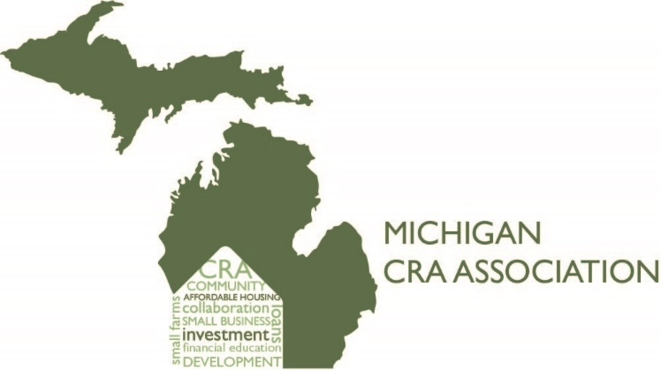

Washtenaw County CRA Association
President’s Report for 2020

Our Mission is to identify the credit needs of our communities and actively promote efforts to meet the credit needs of low and moderate - income individuals and geographies. We aim to serve as the education branch for our Community Reinvestment Associations. This chapter serves the Saginaw County market and collaborate with local nonprofits to provide educational opportunities to low-to-moderate income individuals. We define LMI’s as individuals whose incomes are less than 80% of the area median income.
2019 Events and Activities:
Our membership include the following Banks:
Comerica Fifth Third Bank
Key Bank Bank Flagstar Bank
Huntington Bank Bank of Ann Arbor
Old National Bank PNC Bank
TCF Bank Hanatz Bank
Chemical Bank University Bank

In 2020, during the pandemic, our leadership changed. We elected to take a quiet year in order to make some important dfecisions regarding this association. All officer positions were vacated.

